**A Level Physics at Gateacre**

**Introduction**

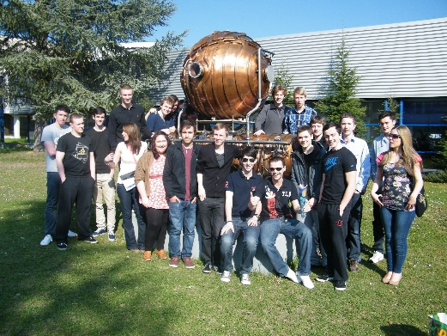A-Level Physics will be taught by Mr Gash and Mr Byrne and has been taught for a number of years with **many successful students** going on to University to study at master’s level in **Maths, Accounting, Engineering, Physics and Astrophysics**.

We will be teaching the AQA Physics A-level specification (7408).

**Course content**

The specification builds on the Combined Science GCSE so **you do not need to have done separate sciences to do the course**. The topics covered in the Physics GCSE will probably be familiar to you from the GCSEs you are doing but will be covered in much more depth.

****The course is split into the following topics (right), taught across 2 years.

**Assessment**

The course is assessed by 3x 2 hour exams at the end of year 13 covering all the topics taught through the 2 years of the course.

**Where can A-Level Physics take me?**

Anywhere! Physics A Level is one of the most respected A levels there is, and it shows you are numerate and can handle a demanding course to a high level. Some people may go onto a Physics degree, but it is a good subject to have for anything, from Psychology to Ecology. It's also a crucial subject for Mathematics and Engineering degrees, and can also be used for entry into Medicine, Law, Accounting, Graphic Design, Geophysics, Architecture and so much more! Geophysics is also a very lucrative area of study where having done Physics is a great advantage**.**

**Entry Requirements**:

* Combined Science – Grade 66
* **or** GCSE Physics – Grade 6

If you have any question please contact the following staff:

* Mr Byrne - [p.byrne@gateacre.org](mailto:p.byrne@gateacre.org)
* Mr Gash - [d.gash@gateacre.org](mailto:d.gash@gateacre.org)

