A Level Physics at Gateacre

Introduction
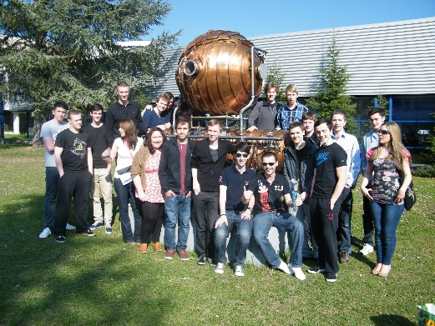
A-Level Physics will be taught by Mr Gash and Mr Byrne and has been taught for a number of years with many successful students going on to University to study at master’s level in Maths, Accounting, Engineering, Physics and Astrophysics.
We will be teaching the AQA Physics A-level specification (7408).

Course content
The specification builds on the Combined Science GCSE so you do not need to have done separate sciences to do the course. The topics covered in the Physics GCSE will probably be familiar to you from the GCSEs you are doing but will be covered in much more depth.
The course is split into the following topics (right), taught across 2 years.

Assessment
The course is assessed by 3x 2 hour exams at the end of year 13 covering all the topics taught through the 2 years of the course.

Where can A-Level Physics take me?
Anywhere! Physics A Level is one of the most respected A levels there is, and it shows you are numerate and can handle a demanding course to a high level. Some people may go onto a Physics degree, but it is a good subject to have for anything, from Psychology to Ecology. It's also a crucial subject for Mathematics and Engineering degrees, and can also be used for entry into Medicine, Law, Accounting, Graphic Design, Geophysics, Architecture and so much more! Geophysics is also a very lucrative area of study where having done Physics is a great advantage.

Entry Requirements – cases considered on an individual basis but Grades 55/66 and higher, including Maths, are usually a good starting point! All cases will be discussed on a case by case basis by the sixth form team.
If you have any question please contact the following staff:
- Mr Byrne - p.byrne@gateacre.org
- Mr Gash - d.gash@gateacre.org


